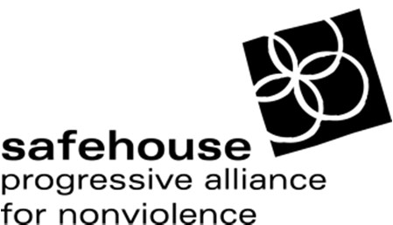
Safehouse Progressive Alliance for Nonviolence (SPAN)

Shelter Child and Youth Counselor, Full Time

Safehouse Progressive Alliance for Nonviolence (SPAN) is a human rights organization committed to ending violence against children, youth, and adults through counseling, advocacy, education, and community organizing. SPAN is a multiethnic, anti-racist, inclusive organization dedicated to peace and non-violence for all survivors and their and families.

Position Overview:
The Shelter Child and Youth Counselor provides therapeutic support, case management and advocacy to children, youth and parents served through the SPAN shelter program; develops and sustains community contacts and resources available to shelter families; promotes a shelter environment based on respect and nonviolence; supports social justice efforts that positively impact children & families.
Responsibilities Include:
- Intakes, assessments, and treatment planning for children and youth within shelter
- Trauma-informed, strengths-based, and client-defined counseling, advocacy, and case management for children, youth, and parents
- Parenting support, intervention, and education regarding parenting issues, child development, and impacts of DV on children & families
- Facilitating play and support groups for children; facilitating psychoeducational support groups for parents
- Expanding and enhancing children and youth program in shelter
- Coordinating referrals and services with community agencies and schools
- Interfacing with Child Protective Services (CPS), and advocating for parents and children involved with CPS
- Assisting in recruitment, training, scheduling & supervision of children’s volunteers and interns
- Assisting with crisis line coverage, shelter screenings and intakes, crisis counseling, advocacy, referrals, and case management for all residents
- Assuring SPAN shelter of coverage, through rotating shifts including weekends, evenings, and holidays
- Maintains client files, timely documentation, and prepares monthly reports and time sheets
- Social justice outreach, education, and organizing; building excellent collaborative relationships with community partners
Qualifications:
- B.A. or equivalent required; Master’s in Counseling Psych, Social Work, or related field preferred
- Excellent interpersonal and community-building skills
- Experience working with children and youth who have witnessed DV, and experienced trauma or abuse
- Strong knowledge of parenting issues and experience working with parents
- Strong written and oral communication skills; Spanish bilingual desired
- Experience & knowledge of social justice issues particularly regarding gender-based violence, privilege and oppression, and systemic inequalities

Pay and Benefits
Annual salary is $30,000 (with increase possible after 6 months), excellent benefits including subsidized health insurance, reduced-rate Eco-Pass, generous vacation time, and work in a dynamic and diverse setting. Strong Commitment to Affirmative Action: SPAN is an EEOA employer

How to Apply:
Please email resume and cover letter to hr@safehousealliance.org

Resume review begins immediately. No calls please.

